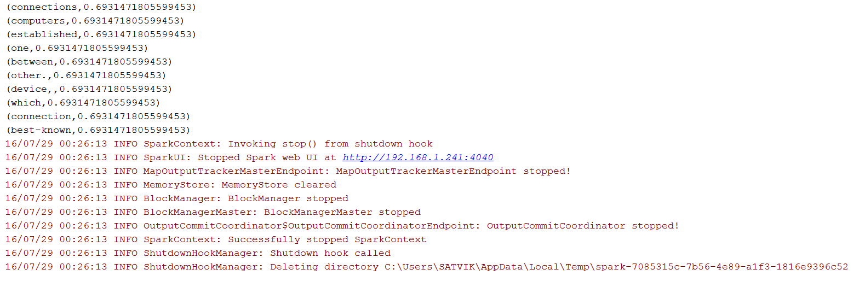

(as,2.0794415416798357)

(be,1.3862943611198906)

(such,1.3862943611198906)

(can,1.3862943611198906)

(The,1.3862943611198906)

(using,1.3862943611198906)

(to,0.8630462173553426)

(able,0.6931471805599453)

(Nodes,0.6931471805599453)

(media.,0.6931471805599453)

(connections,0.6931471805599453)

(computers,0.6931471805599453)

(established,0.6931471805599453)

(one,0.6931471805599453)

(between,0.6931471805599453)

(other.,0.6931471805599453)

(device,,0.6931471805599453)

(which,0.6931471805599453)

(connection,0.6931471805599453)

(best-known,0.6931471805599453)